Add Unique Index to Feature Service

To only allow unique values onto a field, and unique index needs to be applied to the service definition. This can be done by inserting the following code snippet to the definition.

{

"indexes": [

{

"name": "idx_alias",

"fields": "routealias",

"isUnique": true,

"isAscending": false,

"description": "Unique Index Alias Name"

}

]

}

# Apply Manually

To apply manually, you will need to insert the code snippet above into the admin service endpoint. Follow the procedure below, logged in as a Portal admin user.

1. Go to the REST URL for the feature service you want to change
   1. Can get to this URL through Portal, from Item Details click View link next to URL
2. Get to the admin endpoint by putting admin in between *rest* and *services* in the URL. Example:

[https://ermtest5.esri.com/server/rest/**admin**/services/Hosted/Plan_OCC_20210816_t55eooj9fxxbrwwggwrrn/FeatureServer](https://ermtest5.esri.com/server/rest/admin/services/Hosted/Plan_OCC_20210816_t55eooj9fxxbrwwggwrrn/FeatureServer)

1. At bottom of page, click Add to Definition
2. Set the Format = JSON
3. Insert the code snipped above and click addToDefinition

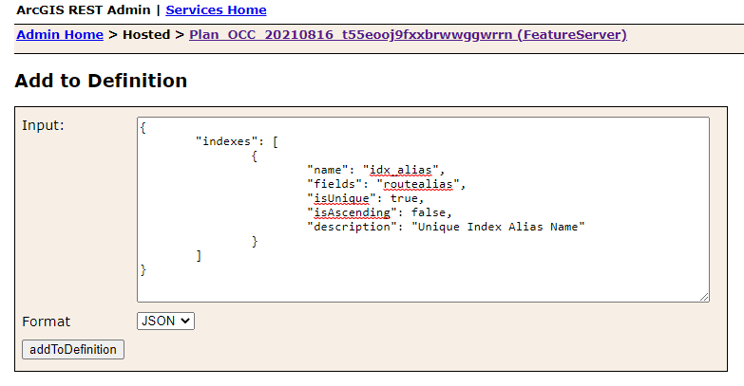

To verify value is set:

1. In Portal, go to the Data page for the feature service
2. Choose Fields view
3. Click the field you wanted to change
4. Check the Unique value

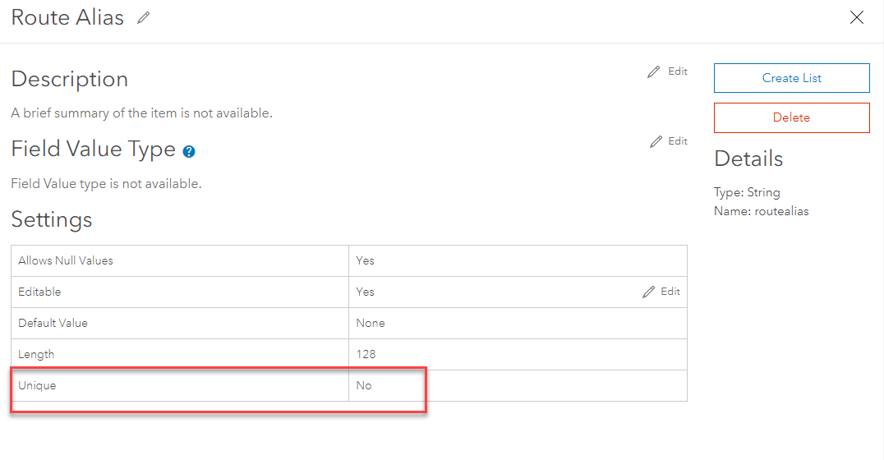

# Apply in Code

Currently when the ERM_Template service is cloned for each plan, the definition does not get carried over, so the unique index needs to be applied to the plan’s feature service after it is created in the BSI.

The developer help links below have code snippets on updating the service definition.

Python API:

<https://developers.arcgis.com/python/guide/updating-feature-layer-properties/>

REST API:

<https://developers.arcgis.com/rest/services-reference/online/add-to-definition-feature-layer-.htm>